The aim of this article is to provide all the necessary info for someone new to extract brewing .
I will try to include all the info I think I would have needed after making a few kit beers to move to extract.
I will assume the brewer knows something about sanitizing their equipment. The tutorial/ pictorial will end after pitching of the yeast.
Temp control, sanitization, yeast starters, secondary fermentation, cold chilling, finings etc are all important aspects of brewing but not specifically related to extract brewing and would blow out this short tutorial into biblical proportions.
Also, I’m not suggesting this is the only way or even the best way to brew extract but after a couple of years of trial and error this simple method gets me excellent results, there’s a 100 ways to skin a cat [ see my other pictorial ].

*remember to remove yeast from fridge and warm up to room temp in advance or prepare your starter and be sure to have ice ready if needed to achieve pitching temp.

The recipe;
For this recipe I will use a boil volume of 5 litres.
What I have done is filled a large pot with 5L of water and then bent a piece of stainless and hung it over the side of the pot as a level indicator [ see image below]. You could use a stainless steel ruler. For a 5L boil I use a 12L pot and occasionally it will threaten to boil over, usually soon after a hop addition. Keep a spray bottle handy, [starsan or water] a quick spray will stop it boiling over.
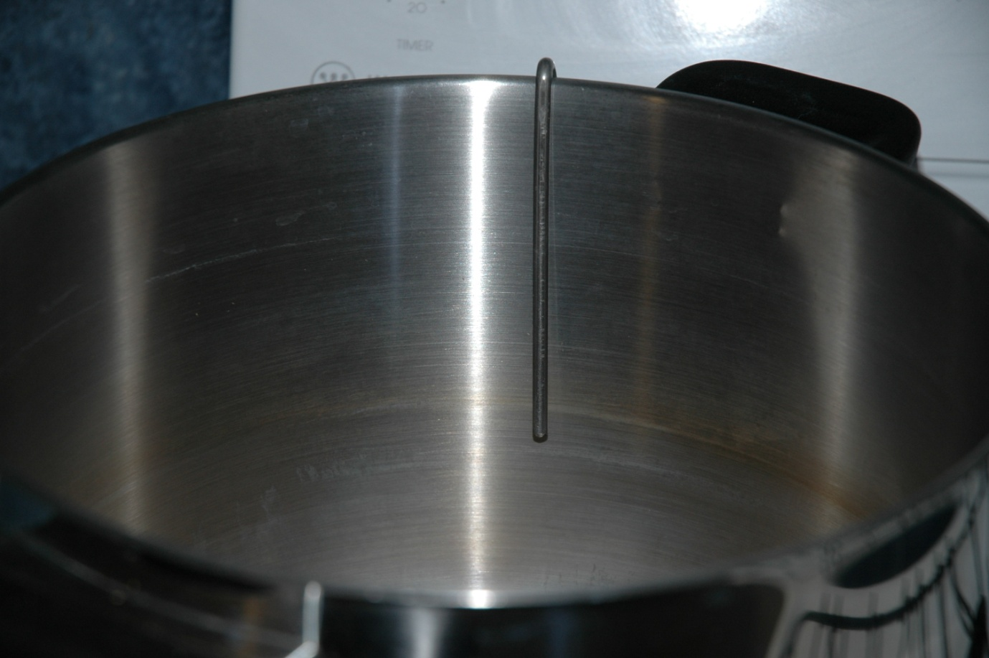
Boil Gravity [BG];
The one aspect of extract brewing people starting out usually have trouble with is with the boil volume and boil gravity[BG]. Look at the BeerSmith recipe sheet below and you will see it says “add water to achieve boil volume of 5L”, and “estimated pre-boil gravity of 1.040”. The gravity of the boil will have a large effect on the bitterness of the final product. Eg, if the BG was 1.030 or 1050 you would end up with about 6-7 more or less IBU’s [international bittering units] respectively.
This may or may not matter, some people would undoubtedly prefer it more or less bitter. For reproduceability and consistency the BG is very important. You could of course add more hops or boil longer or work around it some other way but a generally accepted method is to always have a BG of 1040. Again, consistency at this point is one of the most important parts of the recipe/ brewing. Obviously if you make a recipe with IBU’s of X and the bittering doesn’t suit you then you can adjust it in future but I always keep the BG at 1040.
Also notice on the recipe sheet that there is a small amount of DME/Light Dry Extract at the beginning of the recipe. This is added before the boil with the wort from the steeped grain to achieve the BG of 1040. In the brewing software this small amount has the “add after boil” box unchecked, the remaining cans of goo and dextrose etc will have the “add after boil” box checked, they will be going straight into the fermenter .
The small amount of DME going into the boil might come from a previously opened packet but anything going into the fermenter without being boiled will need to come from an unopened packet or can to reduce the risk of infection. I always formulate/ adjust the extract recipe to facilitate this. If using anything which has been previously opened or repackaged it will need to be boiled for 10 min before going into the fermenter.
Lastly, with respect to the BG, every 15mins during the boil I will top up the pot to the 5L mark with boiling water. The brewing software assumes a boil off rate of 10% per hour by default. I leave that as is and just add boiling water a few times during the boil. Again, consistency is the key. I could measure the boil off and adjust the software then not add water but with a small 5L boil this works well. With such a small boil volume the evaporation rate is more like 30% per hour, maybe even 50%, it would end up like porridge especially if you are making an AIPA with 300g of hops.
I realise most people will want to make a 23L batch instead of 50L, I’ll post the same recipe for 23L at the end [still using a 5L boil], with only 300g of specialty grain in the boil the pre-boil addition of DME will be greater to achieve the BG of 1040. There are a few obvious advantages to boiling 5L instead of boiling the entire 23L-50L batch. For one it is much easier to cool to an appropriate temp to pitch the yeast.

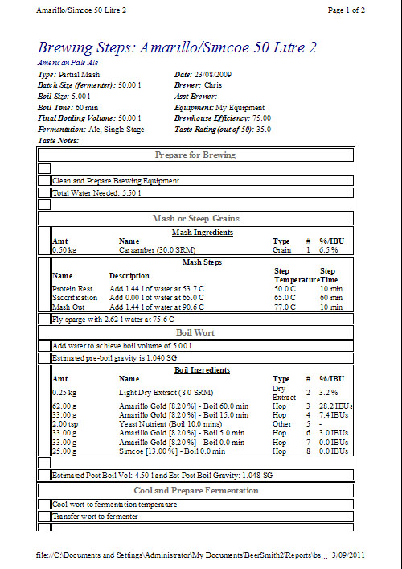
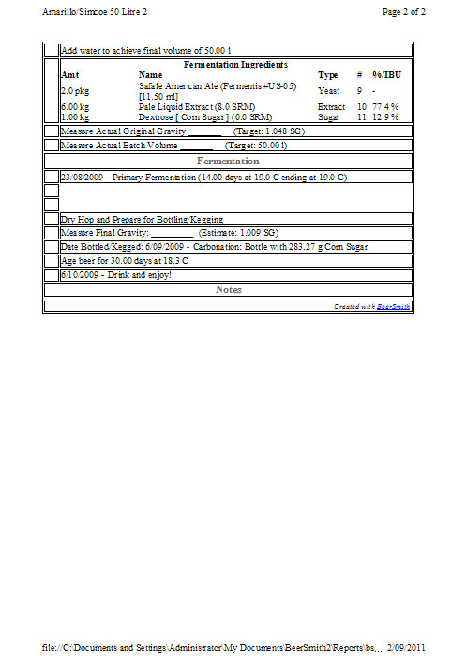

* The software is set to the Tinseth formula for calculating bitterness.
Hops AA%;
Notice the recipe will say something like “ 33g Amarillo [8.7%] – Boil 15.0min Hop 7.9 IBUs”
The 8.7% is the AA rating of the hops which will determine bitterness and will vary between batches. If your Amarillo is say 8.0% instead, you will need more to reach the 7.9 IBUs. Enter the AA% of your batch into the brewing software and adjust the amount to get your 7.9 IBUs. If you don’t have any brewing software you might want to look into it, BeerSmith is a good program but there also some good free programs available which will do the job. ianh’s kit and extract spreadsheet is one of them available here;
http://www.aussiehomebrewer.com/forum/index.php?showtopic=29655&st=260&p=644029&#entry644029
Some recipes will simply quote “ add Amarillo at 15min to achieve 7.9 IBUs”.
The “Boil 15.0min” is discussed further down the article for anyone unsure about it.

Be prepared;
Clear your workspace and have everything you are going to need clean/ sanitized and handy.
You will need to work quickly towards the end of the process and don’t want to have to go looking for your paddle or something and then have to sanitize it or have any problems like that. Sanitize scissors, paddle, thermometer tubing to fill fermenter if used, fermentator etc etc,
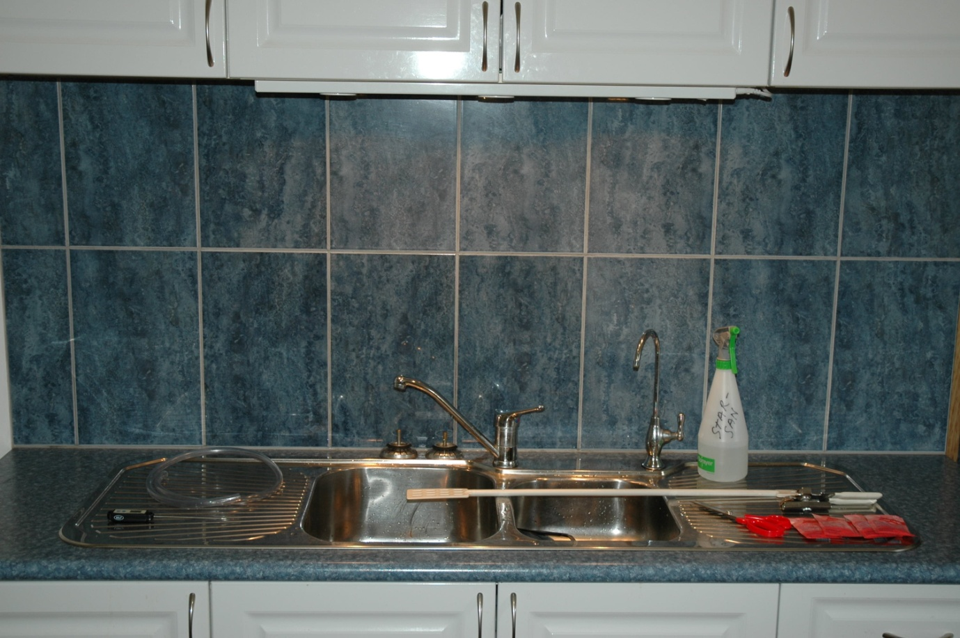
Start;
Steep the grain;
Pre-heat your esky and steep the grain. In this recipe I will add about 2L of 85C water to my small esky then throw in the cracked specialty grain [in a muslin bug] and adjust the temp to about 66C-69C.

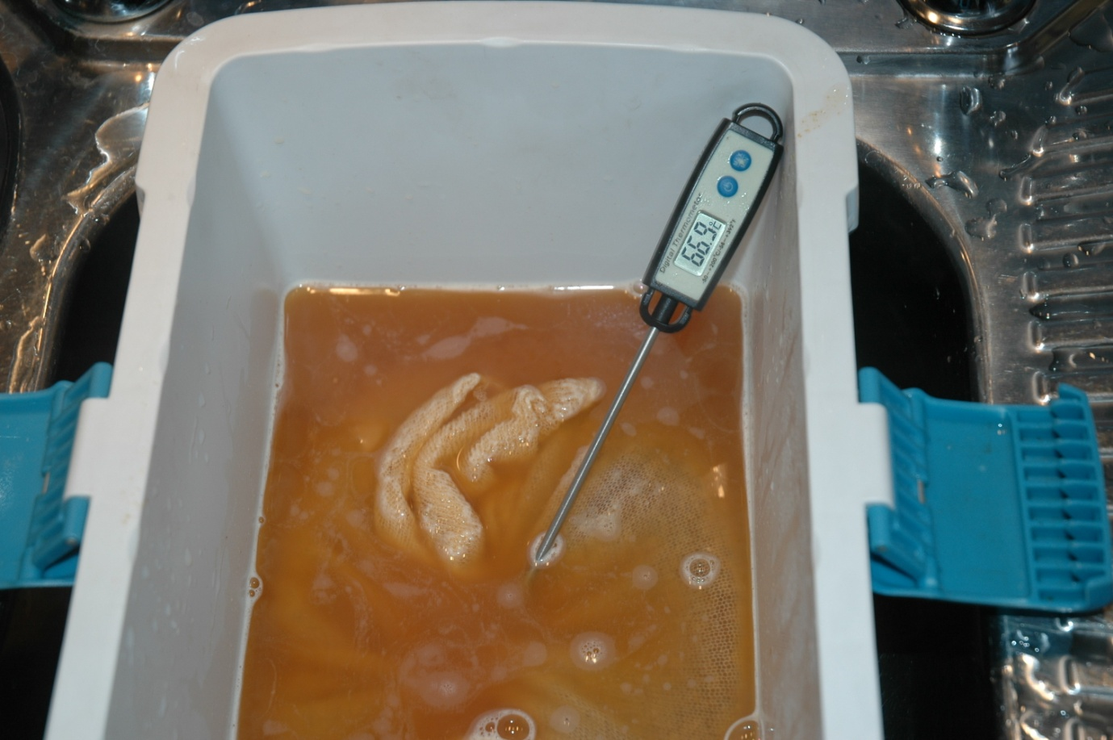
Put the lid on and leave for 30 mins then add about 2L of boiling water to achieve around 75C-78C.
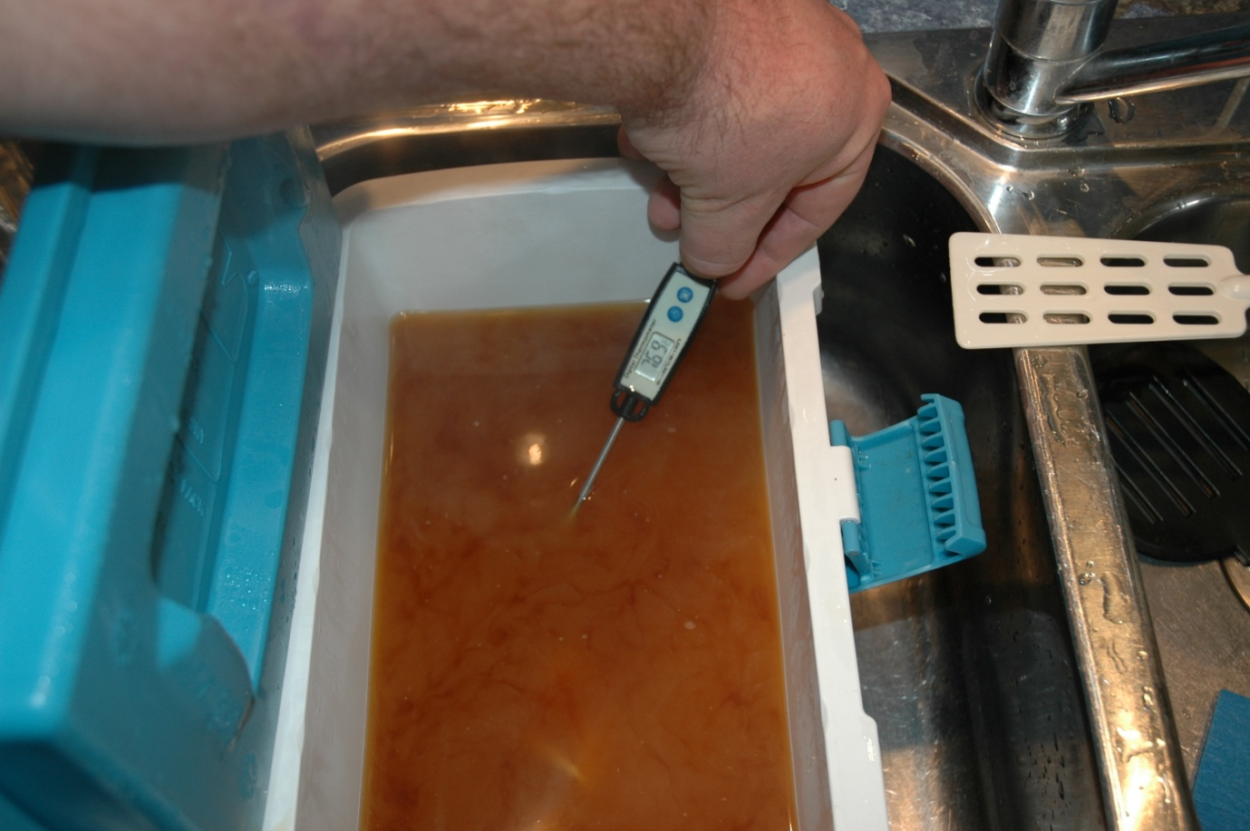
At this point I boil the kettle and then add some tap water to get 78C- 80C

After 5-10 mins I pull out the bag and it place in a strainer on top of the 12L pot, pour the wort into the pot, pour a couple more litres of water at 78C into the esky then let it sit for a few more mins.
Agitate it, pull out the bag and it place in a strainer on top of the 12L pot, pour the wort into the pot.
At this point add the 180g DME as per the recipe to hit your BG of 1040 and top up to 5L [either squeeze the bag then top up or top up by pouring 78C water through the bag, or a bit of both] then bring to the boil on the stovetop.

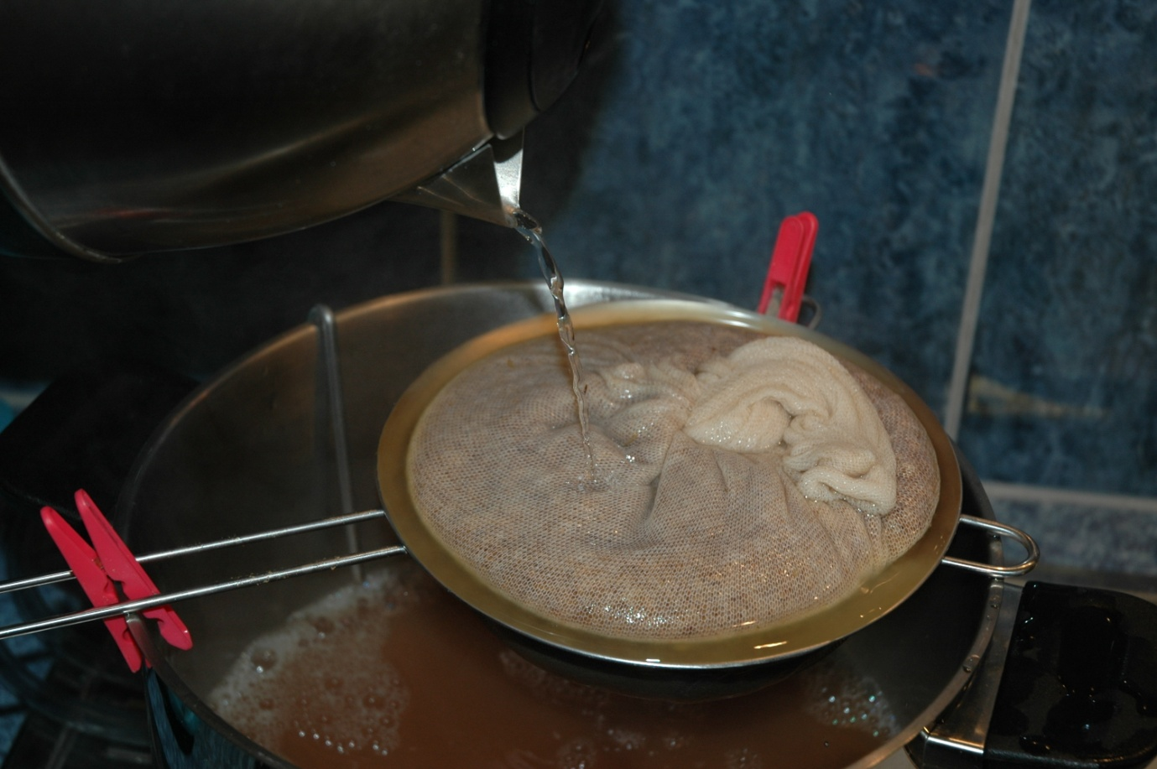
There’s more than one way to do this of course, there is a good article about steeping specialty grain by butters here; http://www.aussiehomebrewer.com/forum/index.php?autocom=ineo&showarticle=80

Adding hops;

Measure out your hops. Refer to the next pic if you are unsure what your’e doing it may make it easier/ help prevent any mistakes.

Once boiling [a good mild rolling boil is ok, no need to boil the bejesus out of it],
set your countdown timer for 60mins and throw in your first hops addition.
For anyone unsure what the additions on the recipe actually mean the next pic should explain it.
If it says eg; “ 28g Amarillo [8.7%] – Boil 15.0” min this means it is added 15mins before the end of the boil. So once the timer counts down to 15 the next cup will go in and be boiled for 15mins until “flame-out”.

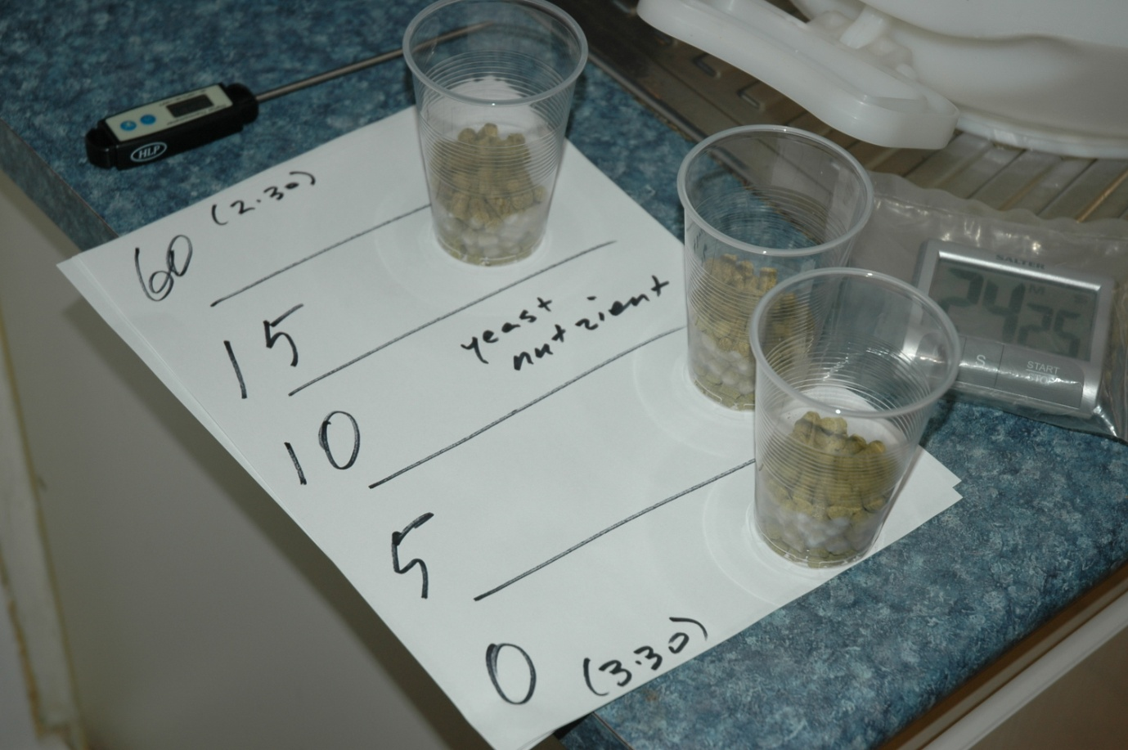

Somewhere towards the end of the boil, maybe after adding the yeast nutrient I will turn the sanitised fermentor the right way up, double check the tap is shut then add the remaining ingredients listed on the recipe sheet, LLME, Dextrose etc . Any cans of LLME etc will have been sitting in the sink full of hot water to thin the goo out a bit making it easier to work with just as you have probably done with any kits.
To preserve hop aroma it is important to mix the wort in the pot with the goo in the fermentor and then cool it as quickly as possible. This is of course more important for an APA or a hop driven beer than for a stout or something where the flavour is focused on the malt or yeast. Make sure everything you need is ready and at hand. The next few minutes after flameout you need to work quickly and being prepared will pay off.

When the timer goes off at 0 min, turn the heat off, add the flameout hops addition then pour the lot straight into the fermentor. There is no need to strain it, the hops will settle on the bottom.
If you have used flowers they will foul up the tap so you will need to use a racking cane or have used a hop sock during the boil or have some other work-around. A sanitized muslin bag for flameout additions should be ok although I’ve never needed to try it, I rack with a cane and use pellets.
Once the wort is in the fermentor with the LLME etc I put the hose straight in there to begin cooling and start mixing with the paddle and/ or swirl the fermentor to mix thouroughly. Once mixed and the fermentor is about ¼ full I add the ice. How much ice will be a bit of trial and error. In winter very little ice is needed for a 50L batch but probably 1-2 kg for a 23L batch. In summer up to 3-4 kg may be needed. I just take a guess and when I get to about 45L I stop and measure the temp, adjust with ice or boiling water and take it from there, doing the same again at about 49L and aiming for 19C-20C. I have usually used ice from the service station and never had a problem or have made my own in ice cream containers. Aerate the wort thoroughly for the benefit of the yeast. Stirring vigorously with an aerating paddle and holding the hose a metre or so above the fermentor seems to have always worked adequately for me. If you aren’t using a hose I have just used the 12 pot used for the boil and filled it from the tap and poured it in.
Job done. Check and record your OG. How you pitch the yeast is a matter of preference. I usually sprinkle dry yeast on top, leave it for 10 min then mix it with a paddle.

-------------------------------------------------------------------------------------------------------------------------------------

I hope this has been helpful to someone, I think it would’ve helped me at the right time.
When I have time I’ll get back here and add some more photos and make any corrections/ elaborate on a few points.
The photos of the grain are carared I took them when making another recipe.
Please pm me with any questions or sensible comments/ corrections.
“dude, why don’t you make AG it’s way better and easy to make” is not a sensible
comment IMO so please don’t bother .

Cheers, Chris. [AHB “glaab”]
--------------------------------------------------------------------------------------------------------------------------------------Same recipe 23L;

